Research Methodology &
Seminar


Research Paper (1)

B.Tech. Semester VI Institute of Technology Nirma University

Prepared By
SARTH NAROLA (23BCE194) NEVIL ANGHAN (23BCE195)

Publication Details :

Title: Federated Learning for Diabetic Retinopathy Diagnosis: Enhancing Accuracy and Generalizability in Under-Resourced Regions
Author Names: Gajan Mohan Raj, Michael G. Morley, Mohammad Eslami
Author Affiliations:
• High Technology High School, USA
• Massachusetts Eye and Ear, Harvard Medical School, USA
• Harvard Ophthalmology AI Lab, Harvard Medical School, USA
Country of Research: USA
Published In: IEEE
Publication Date: Oct 30, 2024
Research Domain Category: Federated Learning, Medical AI, Diabetic Retinopathy,

Privacy-Preserving Deep Learning

Overview
Diabetic Retinopathy (DR) is a leading cause of blindness, especially in under-resourced regions where ophthalmologists and high-quality imaging devices are limited. Centralized deep learning models require sharing sensitive patient data, which violates privacy regulations like HIPAA and GDPR.
Research Problem: How can federated learning improve the diagnostic accuracy and generalizability of diabetic retinopathy classification models across geographically distributed and under-resourced medical institutions while preserving patient data privacy?

Research Gap : Traditional centralized AI models struggle with generalization across diverse institutions and low-quality datasets. There is a need for a privacy-preserving collaborative learning framework that improves diagnostic accuracy while maintaining data confidentiality.

Background & Technical Concepts

• Core Architecture: EfficientNetB0 (selected after comparison with MobileNetV2, InceptionResNetV2, and Xception).
• Federated Algorithm: Federated Averaging (FedAvg).
• Framework Used: TensorFlow Federated (TFF).
• Learning Strategy:
- Local training at institutions
- Model parameter sharing
- Central server aggregation
• Loss Optimization: Stochastic Gradient Descent (SGD), learning rate = 0.001
• Cross-Validation: 5-fold cross-validation
• Early Stopping: 10 epochs

Key Mathematical Metrics

• Accuracy:
- Federated Model (Independent Test Set): 93.21%
- H1 Local Model: 88.76%
- H2 Local Model: 90.36%
- H3 Local Model: 71.48%
• Generalizability Performance (Experiment 2):
- H1 Test Set: 97.08%
- H2 Test Set: 96.34%
- H3 Test Set (Low-quality images): 91.05%
• ROC AUC (EfficientNetB0): 0.934
• Model Size: 29 MB

Datasets & Experimental Analysis
• DDR Dataset (China) – 12,256 images
• EyePACS Dataset (USA) – 11,673 images
• APTOS Dataset (India) – 3,357 images
Each dataset simulated as a separate medical institution:
- H1 → DDR
- H2 → EyePACS
- H3 → APTOS (degraded image quality to simulate under-resourced hospital)
Two Experiments Conducted:
- Experiment 1 – Accuracy Evaluation
Federated model tested on independent 6500-image dataset.
Result: Federated model outperformed all local models.
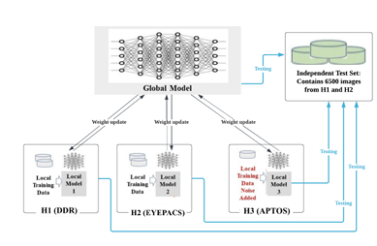
- Experiment 2 – Generalizability Evaluation
Models tested across different institutions.
Result: Federated model showed superior cross-institution generalization.
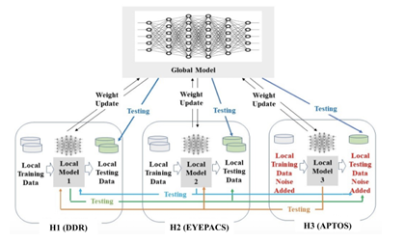

Challenges & Limitation

• No advanced privacy mechanism beyond standard FL (no Differential Privacy or encryption).
• Simulated environment with only 3 institutions.
• Communication cost not deeply analyzed.
• Scalability to large hospital networks not experimentally validated.
• Image quality degradation was simulated artificially.

Results Conclusion

• Federated Learning improved DR classification accuracy to 93.21%.
• Achieved strong generalization even on low-quality images (91.05%).
• EfficientNetB0 provided optimal balance between performance and model size.
• Demonstrated practical deployment via Web and iOS applications.
• Preserved patient privacy by avoiding raw data sharing.

- Why to choose:
• Strong baseline for Federated DR classification.
• Demonstrates real-world hospital collaboration.
• Validates FedAvg effectiveness in healthcare.
• Provides quantitative evidence of improved generalization.
• Deployable AI system with mobile/web application demonstration.

- Why should we not choose:
• Only uses FedAvg (no SCAFFOLD or personalization).
• No Differential Privacy implementation.
• Limited to 3 simulated institutions.
• Does not deeply analyze Non-IID drift correction.
• Security mechanisms are basic (no secure aggregation protocol).

- Task will be do:
• Extend from FedAvg to SCAFFOLD aggregation.
• Introduce Personalized Federated Learning layer.
• Add Differential Privacy / Secure Aggregation.
• Evaluate India vs Europe domain shift explicitly.
• Compare Global vs Personalized Secure FL models.

